**CLIENT AND TOPIC**

This proposal outlines the details of my developer portfolio website. I intend to use it as a jumping off point in the future so that I may engage in freelance work. The website will include personal and relevant information about myself as well as serve as a showcase for professional works added to my portfolio.

**DEVELOPMENT PROCESS AND ENGAGEMENT**

My project’s aim is to serve as a prototype for my professional website. With that in mind, I intend on researching some best practices for UI/UX design and common trends in order to create a user-friendly and engaging design for potential clients. I would also like the end product itself to act as its own example of a portfolio piece, so I will be researching technologies and languages that other developers have used to bring their developer sites to life for both inspiration and knowledge on what could help me be successful. I will also have to strengthen and review my fundamentals of HTML, CSS, and JavaScript markup and coding languages, respectively, to create functional, clean code.

**TESTING**

I won’t have to test client requirements, seeing as I am my client. However, I will look into guides so that I can accurately test things like cross-browser functionality, overall functionality, broken links, and whatever else I may find in my research. Additionally, I will test the website on a variety of screens available to me (Samsung Galaxy phone, iPhone, iPad) to ensure the websites mobile responsiveness.

**DESCRIPTION**

The goal of the “business” is to sell my services as a front-end web developer to businesses or individuals. The website itself will serve as a digital resume of sorts by listing the languages, technologies and other relevant skills for the job. It’ll also include personal, important information about myself and eventually be a place to host larger portfolio builds that are examples of my works.

**Target Audience:**

To market myself primarily to young, new small-business owners and individuals who have portfolios of their own that they would like to have a website for.

**Impact of Target Audience on Design:**

Identifying a target audience will mostly affect my visual presentation of the website. Seeing as I want to start off selling services to individuals, I want to create something clean, accessible, efficient, and aesthetically pleasing – without too many bells and whistles. My website’s content will need to be updated on a fairly regular basis as I add to my portfolio and as I discover the market that I want to represent.

**GROWTH AND MAINTENANCE**

My ultimate goal is to use my website to help me find work in my field. I know that I’m still new with a lot to learn. My expectation is to transform the website’s layout and overall aesthetic as I find my niche – as well as evolve it by implementing new functionalities or reworking some components with new technologies like React/Angular/Python as I learn them to reflect my growth as a programmer. The learning curve is fairly slow for me, so I don’t believe that I will need to update it regularly.

**ORGANIZATION**

The diagram below outlines the basic key components of my website. I prefer the idea of single page websites for something like this so my navigation bar will scroll/jump to the appropriate section of the webpage.

Below is a sample wireframe created with Figma. I added in a sample color palette as well as some design elements. I went a little bit extra on it just so that I could potentially have a better idea as soon as I began coding it myself. I’ve always been a fan of brighter colors, so any feedback on it would be nice. I don’t know if it is overkill or not to be honest.

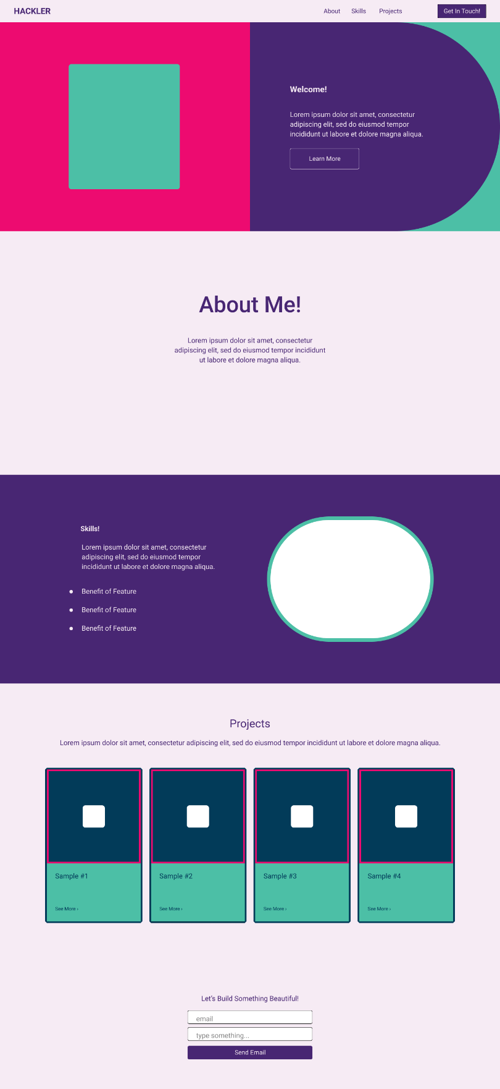

**WEB HOSTING**

I am not very well researched in Web Hosting, so I’d like to find a host that offers security, updates, and backup on its own. Additionally, I will not be seeking hosting until I feel confident enough in my abilities to actually market my services. I don’t ever plan on having downloadable or purchase items from the website itself – instead I would like to use direct communication via email with potential clients. The website will be primarily created with HTML and CSS, but will also require JavaScript for validation of contact form submissions. I will need to research best-practices for SEO purposes and eventually need to use GoDaddy or another site to purchase a domain.

**MARKETING**

For my purposes, most of my early marketing will be verbal. I have a number of friends and colleagues looking for websites as they begin their own small-business plans. However, as I look to expand, I will research key practices for search engine optimization. As my confidence and abilities rise I will utilize my decent following on my social media accounts to reach a larger audience of colleagues and eventually may pay for sponsored ads if my finances allow. I hope to do what I can to make it as a freelance developer, but this marketing may yield unnecessary if I utilize resources like LinkedIn in my job search – where the site itself serves as my personal portfolio and a key component to my digital resume.

**SECURITY**

My website will not be using any form of e-commerce or payment services. Additionally, nothing will be locked to users trying to access my website because nobody will need to create profiles to view and interact with my website. I’ll choose a host offering SSL so that my information is protected and users’ email addresses are protected who choose to contact me. I will keep backups of my site on an external hard drive and a cloud drive.

**REFERENCES**

I did not utilize any references for information purposes on the creation of this project, however, I did utilize tools offered by Figma and Diagrams.net to create my wireframe and flowchart, respectively.

1. Staiano, F. (n.d.). Designing and prototyping interfaces with Figma: Learn Essential UX/UI design principles by creating interactive prototypes for mobile, tablet, and desktop. computer software.
2. JGraph Ltd. (n.d.). diagrams.net. Retrieved April 10, 2023, from https://app.diagrams.net/.

**PROJECT REFLECTION**

The biggest issue I faced in the creation of this project was in determining really the trajectory of how I want this to take me. I’m fairly certain that the end project will look quite different than what I initially anticipated during this development, but I think that is natural. Things shift as you learn more about your own needs, wants, skills, markets, etc.

I used Figma for in depth wireframe creation and diagrams.net for a basic flowchart.